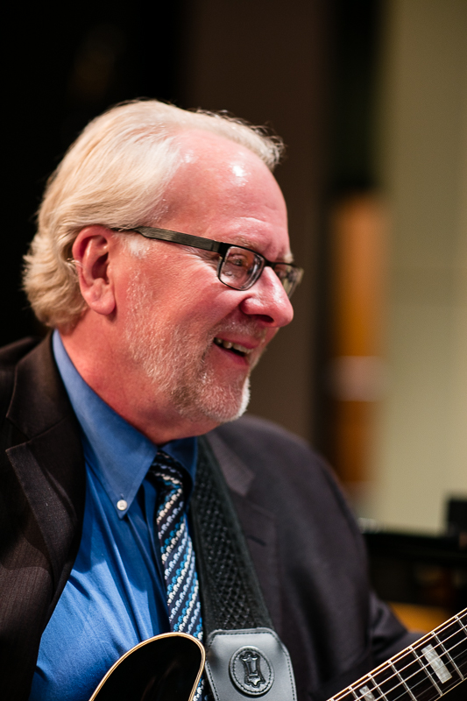
Mike Dana
Composer, educator, and guitarist Mike Dana is currently a faculty member of Jazz Education Abroad, where he performs and teaches regularly in Lebanon, Cyprus, China, Hong Kong, and Thailand. He is also emeritus professor of music at Fresno City College, where he served as Director of Jazz Studies from 1990 to 2018.

Mike’s many compositions and arrangements for instrumental and vocal jazz ensemble are performed all over the world, and are published by Kendor, Alfred, Jazzlines, UNC Jazz Press, and Lorenz. Several have been J. W. Pepper “Editor’s Choice” selections. Recent commissions include charts for the Jazz Education Network, Taipei Jazz Orchestra, and Azusa Pacific University.

Mike holds B.A. and M.A. degrees in composition, with additional studies at the Berklee College of Music and doctoral work at Boston University. He also studied privately with jazz guitar legend Joe Pass. His guitar credits include performances with many jazz greats, including serving as a US State Department cultural envoy to Thailand as a member of the Allison Miller Quartet, and performing with Robin Eubanks and Antonio Hart.

Mike has presented clinics on jazz improvisation, theory, rehearsal techniques, and guitar master classes at the Jazz Education Network national conference, state and regional conferences, universities, and festivals throughout the U.S. He is in demand as an adjudicator, honor group conductor, and artist in residence. Mike was a Grammy Foundation Music Educator of the Year semi-finalist, California Jazz Educator of the Year, and was inducted into the California Alliance for Jazz Hall of Fame.

Mike performs on Eastman guitars, Quilter amplifiers, and Optima strings.
Contact Mike at email: mike@mikedanamusic@com www: mikedanamusic.com

